|  |  |
| --- | --- |
| Semester | T.E. Semester V – Computer Engineering |
| Subject | Software Engineering |
| Subject Professor In-charge | Dr. Sachin Bojewar |
| Assisting Teachers | Prof. Sneha Annappanavar |
| Laboratory | M313B |

|  |  |
| --- | --- |
| Student Name | Deep Salunkhe |
| Roll Number | 21102A0014 |
| TE Division | A |

**Title:** Gantt Chart for College Canteen Order Placement Application



**Explanation:   
Components of a Gantt Chart:**

1. **Task/Activity List**: The first column of a Gantt chart typically lists all the tasks or activities required for the project. In software engineering, these tasks can include requirements gathering, design, coding, testing, documentation, and more.
2. **Timeline**: The top row of the chart represents the project timeline, usually in days, weeks, or months, depending on the project's duration. It starts from the project's beginning date and ends on its completion date.
3. **Bars**: The main part of a Gantt chart consists of horizontal bars, also known as task bars. Each task is represented by a bar that spans the duration it will take to complete. The position of the bar along the timeline indicates when the task starts and ends.

**How Gantt Charts are Used in Software Engineering:**

1. **Task Sequencing**: Gantt charts help software engineers and project managers define the sequence of tasks. Dependencies between tasks are indicated by the order of the bars. For example, coding cannot start until the design phase is complete, so coding would be placed after design in the chart.
2. **Resource Allocation**: Gantt charts allow teams to see when specific resources (e.g., developers, testers, designers) are needed. This helps in resource allocation and prevents overloading or underutilization of team members.
3. **Timeline Management**: By visualizing the timeline, Gantt charts help in setting realistic project schedules and deadlines. You can easily identify critical paths, which are sequences of tasks that, if delayed, will affect the overall project timeline.
4. **Progress Tracking**: As the project progresses, Gantt charts can be updated to reflect actual completion dates and compare them to planned dates. This allows for tracking the project's progress and identifying any delays or deviations from the original plan.
5. **Communication**: Gantt charts are valuable communication tools. They provide a clear and concise way to convey project schedules and progress to stakeholders, team members, and clients. Everyone involved can quickly understand what's happening in the project.
6. **Risk Management**: By visualizing the project schedule, Gantt charts help in identifying potential risks and bottlenecks early in the project. This enables proactive risk management and mitigation strategies.
7. **Scope Management**: Gantt charts can also be used to manage the scope of the project. If new tasks or features are added, they can be inserted into the chart, and their impact on the timeline can be assessed



**Implementation:**

**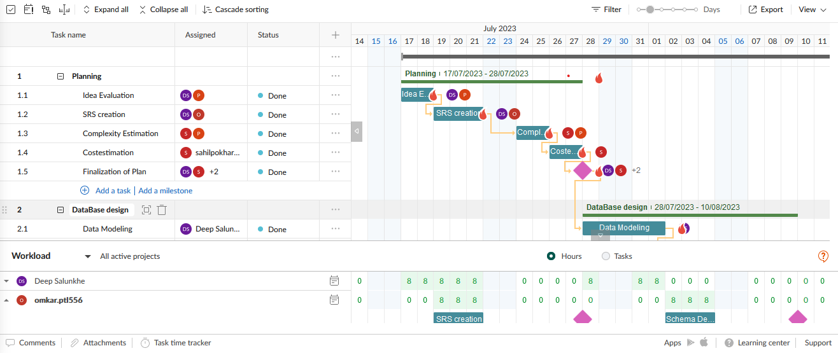  
  
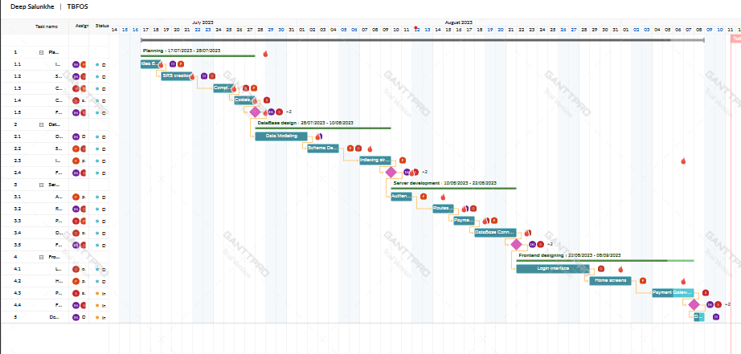  
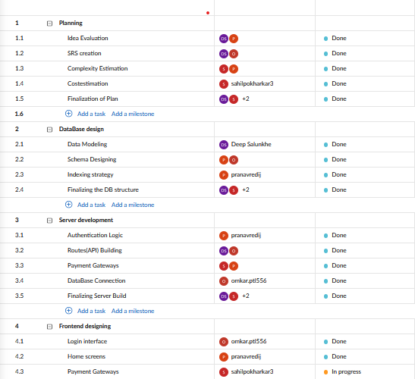**



**Conclusion:**

Gantt charts are valuable in software engineering for project planning, execution, and monitoring. They enhance project transparency, facilitate effective resource management, and assist in delivering software projects on time and within scope.